The title should be clear, concise, and informative, as the titles are used in information-retrieval systems

First Author Full NameA, Second Author Full Name*B, Third Author Full NameB,

the name of the author to be written without title (s)

A Name and address of the affiliate or agency institution
B Name and address of the affiliate or agency institution

*Corresponding author; email: example@apps.ipb.ac.id

Abstract
The abstract should be clear, descriptive, and approximately 250 words in length.

Keywords: Provide a maximum of six keywords. Keywords should not repeat words in Title, alphabetical, avoid using ‘and’ and ‘of’. These keywords will be used for indexing purposes.

Introduction
The manuscript must be written in English. Either American or British English is accepted, but not a mixture of these.

The introduction should state the reasons for doing the work. Please provide a clear and comprehensive background: what was conducted in the research, and why a particular topic and treatments were selected.
Clearly state the objectives of the work.
Avoid a detailed literature review or a summary of the results.
Materials and Methods
Methods should include sufficient detail to allow the work to be reproduced. Methods that are already published should be indicated by a reference.
Results and Discussion
The results section should be presented clearly and concisely. The discussion section should highlight the significance of the results of the work and not repeat the Results section. Avoid extensive citations and discussion of published literature.
The table, picture, and graph must be attached separately.
Conclusions
Provide clear and concise findings of the work.
Acknowledgement
Provide acknowledgements to those who have provided significant contribution, including information concerning research grants (if applicable).
References
Please note that starting February 2022, a minimum of 50% of the references must be articles published in the last 5 years in indexed journals.
Starting July 2025, the references used in the article were written in the style of the APA (author-date citation system).
References are arranged alphabetically with a single space.
Every reference cited in the text must be present in the reference list, and vice versa.
Unpublished results and personal communications should not be included in the reference list; instead, they should be mentioned in the text.
The use of Reference Links is recommended to increase discoverability by online links to the sources cited. Use of DOI is encouraged.
When using Web References, provide both the full URL and the date the reference was last accessed.
All citations in the Reference List should be arranged first alphabetically. More than one reference from the same author(s) in the same year must be identified by the letters 'a', 'b', 'c', etc., placed after the year of publication.
Book:

Kumar, N. (2010). Introduction to floriculture (pp. 73–83). MedTech Science Press.

Journal:

Chozin, M., Garner, J. O., & Watson, C. E. (2006). Inheritance of traits associated with drought resistance in cowpea. Indonesian Agricultural Science Journal, 8(1), 1–5.

Du, Z., Zhou, J., Wang, H., Du, C., & Chen, X. (2006). Potassium movement and transformation in an acid soil as affected by phosphorus. Soil Science Society of America Journal, 70(6), 2057–2064.

Hartatik, W., Husnain, & Widowati, L. R. (2015). The role of organic fertilizer in increasing soil and plant productivity. Land Journal, 9(2), 107–120.

Thesis:
Sayekti, R. S., Prajitno, D., & Toekidjo. (2011). Characterization of eight accessions of cowpea (Vigna unguiculata (L.) Walp) from the Special Region of Yogyakarta [Undergraduate thesis, Gadjah Mada University, Faculty of Agriculture]..

Web References:

Pusat Data dan Sistem Informasi Pertanian. (2019). Statistik konsumsi pangan tahun 2019. https://epublikasi.setjen.pertanian.go.id/388-statistik-konsumsi-pangan-2019]. (Diakses 5 September 2021).

Tables
- Use only one grid for each table and not a grid for each row, and do not use vertical lines to separate columns.
- Tables should be numbered according to their sequence in the text.
- The text should include references to all tables.
- Each table should be typed on a separate page of the manuscript, not included in the text.
- Standard abbreviations of units of measurement should be added between parentheses.
- Explanations essential to the understanding of the table should be given as a footnote at the bottom of the table.
- Tables must be single-spaced.

Table example:
Table 1. The soil chemical properties before cowpea planting*
Soil parameter | Extraction method | Value | Status
pH | H2O | 5.60 | Slight acidic
C-Organic (%) | Walkley and Black | 1.41 | Low
Total N (%) | Kjeldahl | 0.23 | Medium
Available P (P2O5, ppm) | Olsen | 102.65 | Very high
K (cmol(+)/kg) | NH4OAc 1M pH 7.00 | 0.61 | High
CEC (cmol(+)/kg) | NH4OAc 1M pH 7.00 | 18.36 | Medium
Note: *Soil chemical properties criteria according to Sulaeman et al., (2005)

Table 2. Cowpea stomatal density with the application of chicken manure and different rates of N fertilizer
Treatment | Stomatal density (per mm2)
 | Adaxial | Abaxial
Chicken manure (ton.ha⁻¹)
0 | 158.9 | 307.7
5 | 150.2 | 305.40
Rates of N fertilizer (kg.ha⁻¹)
0 | 148.6 | 268.3
22.5 | 173.0 | 324.3
45.0 | 148.5 | 341.3
67.5 | 162.0 | 257.5
90.0 | 141.00 | 341.30
Chicken manure | ns | ns
N fertilizer rates | ns | ns
Chicken manure x N fertilizer rates | ns | ns
Note: ns= not significant according to orthogonal polynomial contrast at α=0.05
Figure/Electronic illustrations
- Supply high-quality printouts of graphics, pictures and other artworks
- Save text in illustrations as "graphics" or enclose the font.
- The following fonts in your illustrations are preferred: Arial, Courier, Helvetica, Times
- Number the illustrations according to their sequence in the text.
- Provide all illustrations as separate files.
- Provide a clear and detailed caption to each graph (see example in Figure 2).
- Produce images at a size close to the desired size of the printed version.
- Do not embed 'graphically designed' equations or tables; please use the word processor's facility.
- Do not import the figures into the text file, but instead, indicate their approximate locations directly in the electronic text and on the manuscript.
Regardless of the application used, please "save as" or convert the images to one of the following formats:

TIFF: Color or greyscale photographs: always use a minimum of 300 dpi.
TIFF: Bitmapped line drawings: use a minimum of 1000 dpi.
TIFF: Combinations bitmapped line/half-tone (color or greyscale): a minimum of 500 dpi is required.
Example:

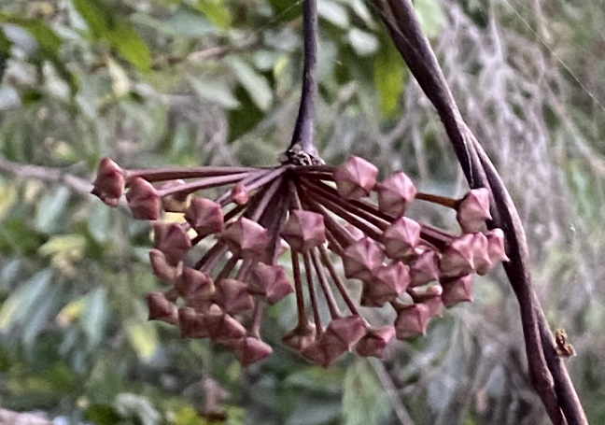

Figure 1. Hoya pubicalyx inflorescence; bar=10 mm.

Figure 2. Chrysanthemum morifolilum stem elongation when treated with paclobutrazol. Stem elongation was determined at 56 days after planting following two drenches with milliQ water (control) or paclobutrazol at three concentrations (0.02, 0.2, and 2 mg.L⁻¹). Experiments were repeated three times (March, June, and September 2019) using five blocks of 15 plants per treatment per trial. Differences between means are denoted with * (α = 0.05), ** (α = 0.01), or ns (not significant) according to Fisher mean separation.

