Titles Should be Clear, Concise, and Informative, as Titles are Used in Information-Retrieval Systems. Font Arial 14 is to be Used to Write the Title

First Author Full Name¹, Second Author Full Name*^{1,2}, Third Author Full Name¹, the name of the author to be written without title (s)

¹ Name and address of the affiliate or agency institution
² Name and address of the affiliate or agency institution

*Corresponding author; email: example@apps.ipb.ac.id

Abstract

The abstract should be clear, descriptive, and approximately 250 words in length.

Keywords: Provide a maximum of six keywords. Keywords should not repeat words in the Title, alphabetically. Avoid using ‘and’ and ‘of’. These keywords will be used for indexing purposes.

Introduction

Font Arial 11 is to be used to write the Introduction, Materials and Methods, Results and Discussion, Conclusions, Acknowledgements, and References. Manuscript must be written in English. Either American or British English is accepted, but not a combination of the two. The introduction should state the reasons for doing the work. Please provide a clear and concise background that explains why the study is essential and states the objectives of the work. Avoid a detailed literature review or a summary of the results.

Materials and Methods

Methods should include sufficient detail to allow the work to be reproduced. Methods that are already published should be indicated by reference (s).

Results and Discussion
The results section should be presented clearly and concisely. The discussion section should highlight the significance of the results of the work and not repeat the Results section. Avoid extensive citations and discussion of published literature.

Conclusions

Provide clear and concise conclusions about the work.

Acknowledgement

Provide acknowledgements to those who have provided significant contributions, including information concerning research grants (if applicable).

References

A minimum of 50% of the references must be articles published in the last 5 years in indexed journals.

Starting July 2025, the references used in the article were written in the style of the APA (author-date citation system). References are arranged alphabetically with a single space. Every reference cited in the text must be present in the reference list, and vice versa. Unpublished results and personal communications should not be included in the reference list; instead, they should be mentioned in the text.

The use of Reference Links is recommended to increase discoverability by online links to the sources cited. Use of DOI is encouraged. When using Web References, provide both the full URL and the date the reference was last accessed. All citations in the Reference List should be arranged first alphabetically. More than one reference from the same author(s) in the same year must be identified by the letters 'a', 'b', 'c', etc., placed after the year of publication.

Book:
Kumar, N. (2010). Introduction to floriculture (pp. 73–83). MedTech Science Press.

Journal:
Chozin, M., Garner, J. O., & Watson, C. E. (2006). Inheritance of traits associated with drought resistance in cowpea. Indonesian Agricultural Science Journal, 8(1), 1–5.

Du, Z., Zhou, J., Wang, H., Du, C., & Chen, X. (2006). Potassium movement and transformation in an acid soil as affected by phosphorus. Soil Science Society of America Journal, 70(6), 2057–2064.

Hartatik, W., Husnain, & Widowati, L. R. (2015). The role of organic fertilizer in increasing soil and plant productivity. Land Journal, 9(2), 107–120.

Thesis:
Sayekti, R. S., Prajitno, D., & Toekidjo. (2011). Characterization of eight accessions of cowpea (Vigna unguiculata (L.) Walp) from the Special Region of Yogyakarta [Undergraduate thesis, Gadjah Mada University, Faculty of Agriculture].

Web References:
World Health Organization. (2018, March). Questions and answers on immunization and vaccine safety. https://www.who.int/features/qa/84/en/.

Tables
- Use only one grid for each table and do not use vertical lines to separate columns.
- Tables should be numbered according to their sequence in the text.
- The text should include references to all tables
- Standard abbreviations of units of measurement should be added between parentheses.
- Explanations essential to the understanding of the table should be given as a footnote at the bottom of the table.
- Tables must be single line spacing

Table example:

Table 1
The Soil Chemical Properties Before Cowpea Planting*
Soil parameter | Extraction method | Value | Status
pH | H₂O | 5.60 | Slight acidic
C-Organic (%) | Walkley and Black | 1.41 | Low
Total N (%) | Kjeldahl | 0.23 | Medium
Available P (P₂O₅, ppm) | Olsen | 102.65 | Very high
K (cmol(+)/kg) | NH₄OAc 1M pH 7.00 | 0.61 | High
CEC (cmol(+)/kg) | NH₄OAc 1M pH 7.00 | 18.36 | Medium
Note. *Soil chemical properties criteria according to Sulaeman et al. (2005).

Table 2
Cowpea Stomatal Density with the Application of Chicken Manure and Different Rates of N Fertilizer
Treatment | Stomatal density (per mm²)
Treatment | Adaxial | Abaxial
Chicken manure (ton/ha)
0 | 158.9 | 307.7
5 | 150.2 | 305.4
Rates of N fertilizer (kg/ha)
0 | 148.6 | 268.3
22.5 | 173.0 | 324.3
45.0 | 148.5 | 341.3
67.5 | 162.0 | 257.5
90.0 | 141.0 | 341.3
Chicken manure | ns | ns
N fertilizer rates | ns | ns
Chicken manure x N fertilizer rates | ns | ns
Note. ns = not significant according to orthogonal polynomial contrast at α=0.05.

Figure/Electronic illustrations

- Supply high-quality printouts of graphics, pictures, and other artworks
- Save text in illustrations as "graphics" or enclose the font.
- The following fonts in your illustrations are preferred: Arial, Courier, Helvetica, Times
- Number the illustrations according to their sequence in the text.
- Provide all illustrations as separate files.
- Provide a clear and detailed caption for each graph. See example in Figure 2.
- Produce images near the desired size of the printed version.
- Do not embed 'graphically designed' equations or tables; please use the word processor's facility.

Regardless of the application used, please "save as" or convert the images to one of the following formats.

TIFF: Color or greyscale photographs: always use a minimum of 300 dpi.
TIFF: Bitmapped line drawings should use a minimum resolution of 1000 dpi.
TIFF: Combinations bitmapped line/half-tone (color or greyscale): a minimum of 500 dpi is required.
Example:

Figure 1
Hoya Pubicalyx Inflorescence
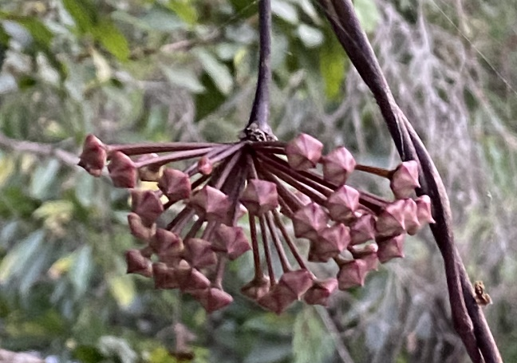
Note. Bar=10 Mm.

Figure 2
Chrysanthemum morifolium Stem Elongation when Treated with Paclobutrazol
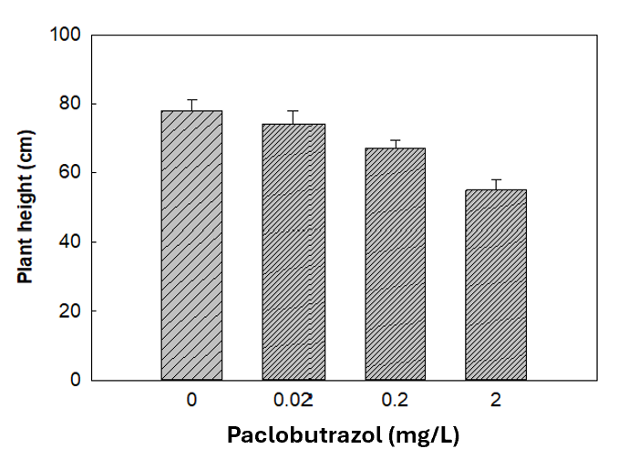
Notes. Stem elongation was determined 56 days after planting, following two drenches with milliQ water (control) or paclobutrazol at three concentrations (0.02, 0.2, and 2 mg/L). Experiments were repeated three times (March, June, and September 2022) using five blocks of 15 plants per treatment per trial. Differences between means are denoted with * (α = 0.05), ** (α = 0.01), or ns (not significant) according to Fisher mean separation.

